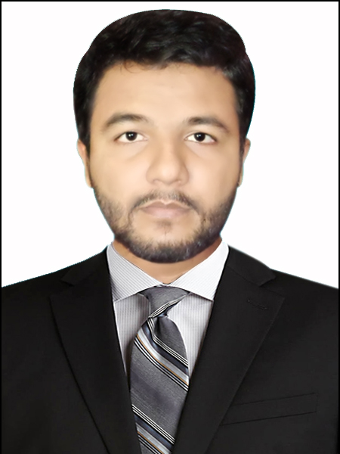
RESUME OF | SHAHINUR ISLAM
Date | 06/01/2025
EMAIL | shahinu.islam.robin@gmail.com
Mobile | 01856101268

Objective
Looking for hard and Challenging Job where I will have the scope to utilize my potentiality, adaptability and skill to do something innovate and from where I will be able to enhance my knowledge.

Academic Qualifications:

Name of Degree: Bachelor of Social Science (BSS)
Institute : Hamdard University Bangladesh
Concentration : Economics
Result : 2.74
Passing Year : 2020

Name of Degree: H.S.C (Higher Secondary School Certificate)

Institute : Govt. Gazaria Collage
Group : Arts
Passing Year : 2015
G.P.A : 3.00 (Out of 5.00)
Board : Dhaka

Name of Degree: S.S.C (Secondary School Certificate)

Institute : Gazaria Pilot High School
Group : Sceience
Passing Year : 2013
G.P.A : 3.31 (Out of 5.00)
Board : Dhaka

Computer Skill:
I have good command on Microsoft Office Application Program such as Microsoft Word, Excel, Power Point, Excess, Internet Browsing
E-mail, PDF converting & documentation etc.

Language Proficiency:
- Having good command in reading , speaking and writing in English
- Having good command in reading , speaking and writing in Bengali

Interest
Reading novel and Humorous Story, Traveling, and Sports.

Strengths
Hard working, Self-motivated, Enthusiastic and
Punctual, Dynamic and creative in thinking.
Sense of good organizational behavior.

Personal information
Name : Shahinur Islam
Father’s Name : Rafiqul Isalm
Mother’s Name : Sajeda Begum
Residential Address (Permanent) :

Village :Prodhaner Char

P.O. : Gazaria

P.S: : Gazaria

Dist. : Munshiganj.

Date of birth : 01/06/1997
Religion : Islam
Marital Status : Unmarried
Gender : Male
Nationality : Bangladeshi (By Birth)

Signature
(Shahinur Islam)

